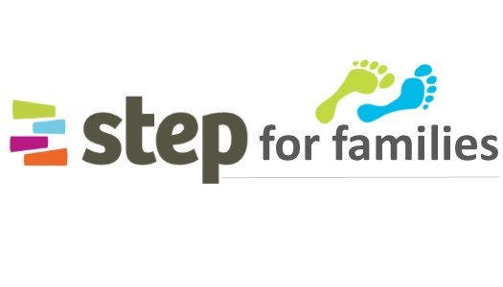
Strengthening community
Transforming families
Enriching opportunities
Preparing children
Enrichment for Youth & Families Program
Request for Proposal

- The Edgar May Health and Recreation Center’s Youth and Family Enrichment Program is seeking to develop a partnership with members of our community to increase opportunities for youth and families to participate in quality experiences and enrichment opportunities. Building connections with the community and supporting quality educational and family time has research-supported benefits of future success.

- The STEP Program has a goal of providing various enrichment opportunities led by community members ranging from experts to hobbyists. Do you have a special skill, project, or hobby that you would like to share or teach to a group of six (6) to eight (8) youth and/or their parent(s)? We are seeking proposals for a new enrichment program that would provide a weekly class or workshop, 30-60 minutes in length, which would last 4-6 weeks. What’s your passion? What would you would like to share with our community’s youth and their parents?

- A stipend of up to $250 per session would be paid to each facilitator and a budget for materials would be available. Classes or workshops should be 30-60 minutes per week and run 4-6 weeks in duration. Up to 8 youth, and sometimes an accompanying adult(s), would participate....

- Requirements: Complete attached proposal for a program that you would be interested in hosting. Include the course description, targeted audience or participants, and needed materials.

- Location: The Edgar May can help provide a location for the activity, although if you have access to space, please include that information in the proposal.

- Submission deadline: In order to be included in a Winter/Spring program calendar, please submit your proposal no later than November 17, 2017. Proposals may be submitted after this date for consideration in the Summer/Fall program calendar.
- Principal Point of Contact: Sarah Tilden-Gramling, Youth & Family Program Coordinator or Christian Craig, Executive Director at 802-885-2568
Strengthening community
Transforming families
Enriching opportunities
Preparing children

Applicant/Facilitator Name: Click here to enter text.
Affiliation: Click here to enter text.
Certification(s): Click here to enter text.
Please describe a program that you would like to facilitate/teach/introduce to local youth and adults: Click here to enter text.

Preferred/Target Age(s): Click here to enter text.
Duration of program: Four (4) weeks Six (6) weeks One time/Stand Alone program
Preferred/Ideal day/time to offer this program: Click here to enter text.
Materials needed: Click here to enter text.
Location where the program will take place (type of space required): Click here to enter text.
Additional comments (optional): Click here to enter text.

